„In the dark ages the names disappear, but the art remains, making the body obedient the spirit.”

MASTER CUP 2013 GENARAL INFORMATION

DATE:

12th of October (Saturday) – VI Master Cup 2013

VENUE:

Martial Arts Sports Hall in Wrocław (Olympic stadium) - AWF, ul. Paderewskiego 35

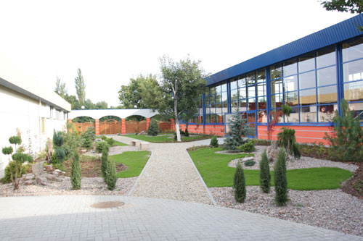
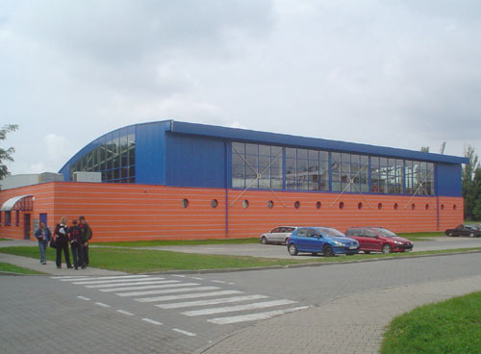

ORGANIZER:

Traditional Karate Club “KOBU” Wroclaw Association
ul. Lodzka 23, 50 – 521 Wroclaw
www.kobu.pl e-mail: kobu@home.pl
Phones: Lukasz Wojcik, tel.:+48 603-318-310,

Lower Silesian Regional Traditional Karate Associacion (Dolnoslaski Okregowy Zwiazek Karate Tradycyjnego)
ul. Grabiszynska 279, 53-234 Wroclaw

UNDER HONORARY PATRONAGE:
Japanese Embassy in Poland
Traditional Karate Federation of Poland

PROGRAM:

12th of October 2013 (Saturday)
08:00 - 9:30 - Registration of competitors
09:45 - Official Commencement
13:00 - 14:15 – Lunch & technical break
14:30 - 18:00 – Decoration of competitors and continuation of tournament.
21:00- Dinner for invited guests and VIPs.
- Starting list together with time schedule to each age group will be shortly established and sent to all clubs interested in Master Cup 2013.

ENTRY FEE:

Children (Group A & B) and Youth – 40PLN
Juniors and Cadets – 40PLN for first choice, and 20PLN for the next one;
Seniors – 90PLN (kumite – men and fukugo – women) and 20PLN for the next one (kata)

Payment is required directly at Master Cup Reception on the day of arrival by team coach or through bank account:

SWIFT: WBKPPLPP
WBK BANK
BANK ACCOUNT: PL 08 1090 1522 0000 0001 0651 7264
KKT KOBU – WROCLAW STOWARZYSZENIE
UL. LODZKA 23, 50-524 WROCLAW, POLAND

AWARDS:

Women-seniors:
I place in fukugo - Gold medal and monetary award of 1500PLN
II place in fukugo - Silver medal and monetary award of 1000PLN
III place in fukugo - Bronze medal and monetary award of 500PLN

Men-seniors:
I place in KUM ITE – Gold medal and monetary award of 1500PLN
II place in KUM ITE – Silver medal and monetary award of 1000PLN
III place in KUM ITE – Bronze medal and monetary award of 500PLN

*MONETARY AWARDS RE VALID IF MINIMUM 15 WOMEN AND 45 MEN TAKE PART IN COMETITION BEING PRIZED.

The winners in other categories receive certificates, special medals and unique prizes.

GENERAL CONDITIONS

- Appropriate age to the category;
- Appropriate level registered ITKF;
- Valid medical examination from physician specialized in sport medicine or certified Polish Society of Sports Medicine;
- Valid accident insurance;
- Written approval from legal guardian in order to participate in competitions.

